Unit 1: Computer Fundamentals
Computer:-
Computer is an electronic device that processes data according to instructions provided by software programs. It takes input (data), processes it using a central processing unit (CPU), stores information, and produces output (results) to perform various tasks. It is widely used in fields such as education, business, communication, and entertainment for efficient and accurate operations.
A computer system is a combination of hardware and software that works together to receive data, process it, store it, and produce useful information.
For example, a computer system includes physical components such as the CPU, keyboard, monitor, and memory, as well as software such as the operating system and applications.

Characteristics and Applications of Computers

1. Characteristics of Computers
The characteristics of a computer are the special features that make computers useful and powerful.

1. High Speed
A computer can perform millions or billions of calculations in a very short time. It can process large amounts of data much faster than humans.
Example: Calculating the marks and percentage of thousands of students.

2. Accuracy
A computer produces highly accurate results when the data and instructions given to it are correct.
Example: Preparing salary sheets and calculating taxes.

3. Diligence
A computer does not become tired or bored. It can perform the same task repeatedly with the same efficiency.
Example: Processing thousands of bank transactions continuously.

4. Large Storage Capacity
Computers can store a large amount of data and retrieve it whenever required.
Example: Storing documents, photographs, videos, student records, and databases.

5. Automation
Once a computer is given the necessary instructions and data, it can perform tasks automatically with little or no human intervention.
Example: Automatic generation of monthly electricity bills.

6. Versatility
A computer can perform different types of tasks such as calculations, communication, designing, programming, entertainment, and data processing.
Example: The same computer can be used for teaching, programming, browsing, and watching videos.

7. Reliability
Computers can perform tasks consistently for long periods with a low chance of error caused by fatigue.
Example: Computers are used for continuous monitoring in industries and servers.

8. Multitasking
A computer can handle multiple tasks at the same time.
Example: A user can listen to music, browse the internet, download a file, and edit a document simultaneously.

9. Communication
Computers can communicate and exchange information through computer networks and the Internet.
Example: Email, video conferencing, online meetings, and instant messaging.

10. Programmability
A computer can be programmed to perform different tasks according to the instructions provided by the user.
Example: Programming a computer to calculate student results or manage inventory.

Applications of Computers
Computers are used in almost every field of modern life.
Field | Applications
Education | - Online classes, e-learning, examinations, presentations, digital libraries
Business | - Accounting, billing, payroll, inventory, sales management
Banking | - ATM, online banking, transaction processing, account management
Healthcare | - Patient records, medical imaging, diagnosis support, hospital management
Communication | - Email, video calls, social media, messaging
Science & Research | - Data analysis, simulations, experiments, scientific calculations
Engineering | - CAD, design, simulation, project management
Entertainment | - Movies, music, games, video editing
Government | - Digital records, taxation, public services, online forms
Transportation | - Ticket booking, navigation, traffic control, vehicle management
Industry | - Automation, robotics, production control, quality checking
E-commerce | - Online shopping, digital payment, order and delivery management
Defense | - Communication, simulation, monitoring, information processing
Agriculture | - Weather monitoring, crop management, smart irrigation
Home | - Online banking, education, shopping, entertainment, smart-home control

Applications of Computers :-
- Education: Computers are used for online classes, e-learning, presentations, and digital libraries.
They help teachers prepare lessons and students learn and research easily.
- Business: Computers are used for accounting, billing, payroll, inventory, and data management.
They help businesses perform daily operations quickly and accurately.
- Banking: Computers are used for ATM services, online banking, account management, and transactions.
They make banking services faster, safer, and available 24/7.
- Healthcare: Computers are used to maintain patient records, medical imaging, diagnosis, and hospital management.
They help doctors and hospitals manage information efficiently.
- Communication: Computers are used for email, video conferencing, messaging, and social media.
They allow people to communicate and share information from anywhere.
- Science and Research: Computers are used for complex calculations, simulations, experiments, and data analysis.
They help researchers process large amounts of scientific data quickly.
- Engineering: Computers are used for designing, modeling, simulation, and technical calculations.
CAD software helps engineers create accurate designs and drawings.
- Entertainment: Computers are used for watching movies, listening to music, playing games, and editing videos.
They provide various forms of digital entertainment.
- Government: Computers are used for maintaining records, taxation, online services, and public administration.
They help government offices provide services quickly and efficiently.
- Transportation: Computers are used for ticket booking, navigation, traffic management, and vehicle control.
They help make transportation systems faster, safer, and more organized.
- Industry: Computers control machines, robots, production processes, and quality checking.
They increase productivity and reduce human effort in manufacturing.
- E-commerce: Computers are used for online shopping, digital payments, order processing, and customer management.
They allow customers to buy products and services through the Internet.
- Defense: Computers are used for communication, monitoring, simulation, and information processing.
They help defense organizations manage and analyze large amounts of information.
- Agriculture: Computers are used for weather forecasting, crop monitoring, irrigation management, and farm planning.
They help farmers improve productivity and make better decisions.
- Home: Computers are used for study, entertainment, online shopping, banking, and communication.
They make many everyday activities easier and more convenient.

Generations and Classification of Computers

Generations of Computers

1. First Generation (1940–1956)
- First-generation computers used vacuum tubes for processing.
- They used machine language for programming.
- They were very large, expensive, and slow compared with modern computers.
- They consumed a lot of electricity and produced excessive heat.
- Their storage mainly used magnetic drums.
- Examples: ENIAC, UNIVAC-I, and EDSAC.

2. Second Generation (1956–1963)
- Second-generation computers used transistors instead of vacuum tubes.
- They were smaller, faster, cheaper, and more reliable.
- They consumed less electricity and produced less heat.
- Assembly language and high-level languages such as FORTRAN and COBOL were used.
- Magnetic core memory was commonly used.
- Examples: IBM 1401, IBM 7094, and CDC 1604.

3. Third Generation (1964–1971)
- Third-generation computers used Integrated Circuits (ICs).
- ICs contained many electronic components on a single chip.
- Computers became smaller, faster, more reliable, and less expensive.
- Operating systems and high-level programming languages became more common.
- They supported features such as multiprogramming and time-sharing.
- Examples: IBM System/360, PDP-8, and PDP-11.

4. Fourth Generation (1971–Present)
- Fourth-generation computers use microprocessors based on VLSI technology.
- Thousands or millions of components can be placed on a single chip.
- Computers became very small, powerful, affordable, and reliable.
- Personal computers, laptops, and modern networking developed rapidly.
- Graphical user interfaces, databases, and advanced software became common.
- Examples: IBM PC, Apple Macintosh, modern desktops, and laptops.

5. Fifth Generation (Present and Beyond)
- Fifth-generation computers focus on Artificial Intelligence (AI) and intelligent computing.
- They use technologies such as parallel processing, machine learning, and natural language processing.
- They are designed to understand and respond to human-like commands.
- Robotics, expert systems, speech recognition, and computer vision are important applications.
- Modern AI systems can learn from data and perform complex tasks.
- Examples: AI assistants, intelligent robots, autonomous systems, and AI-based computers.

Classification of Computers Based on Size

1. Microcomputer
- Microcomputers are small computers designed mainly for individual users.
- They generally use a microprocessor as the CPU.
- They are relatively inexpensive and easy to use.
- They are commonly used in homes, schools, offices, and businesses.
- Examples include desktop computers, laptops, tablets, and smartphones.
- They are also commonly called personal computers (PCs).

2. Minicomputer
- Minicomputers are medium-sized computers that are more powerful than typical microcomputers.
- They can support multiple users simultaneously.
- They were commonly used by universities, laboratories, and medium-sized organizations.
- They provide greater processing and storage capacity than traditional personal computers.
- They were often used for database and industrial applications.
- Examples: DEC PDP-8 and PDP-11.

3. Mainframe Computer
- Mainframe computers are large and powerful computers designed to process huge amounts of data.
- They can support hundreds or thousands of users simultaneously.
- They provide high reliability, security, and availability.
- They are widely used for banking, insurance, airlines, and government systems.
- They can handle millions of transactions and large databases efficiently.
- Examples: IBM zSeries and IBM Z mainframes.

4. Supercomputer
- Supercomputers are the most powerful computers in terms of computational performance.
- They perform extremely large and complex calculations at very high speeds.
- They use thousands of processors working together through parallel processing.
- They are used for weather forecasting, scientific research, simulations, and space research.
- They are also used in areas such as nuclear research and advanced AI computation.
- Examples: Frontier, Aurora, and Fugaku.

Computer Architecture
Computer architecture refers to the design, organization, and functional structure of a computer system. It explains how different components of a computer are connected and how they work together to execute instructions and process data.

Main Components of Computer Architecture
- Input Unit
It accepts data and instructions from the user and converts them into a form that the computer can understand.
Examples: Keyboard, mouse, scanner.
- Central Processing Unit (CPU)
The CPU is the main processing unit of a computer. It executes instructions and controls other components.
It consists mainly of the ALU, Control Unit, and Registers.
- Arithmetic Logic Unit (ALU)
ALU performs arithmetic operations such as addition and subtraction.
It also performs logical operations such as AND, OR, NOT, and comparisons.
- Control Unit (CU)
The Control Unit controls and coordinates all operations of the computer.
It fetches instructions from memory, decodes them, and directs other units to execute them.
- Memory Unit
Memory stores data, instructions, and intermediate results required during processing.
It includes primary memory such as RAM and ROM and secondary storage such as HDD and SSD.
- Output Unit
The output unit converts processed information into a form that users can understand.
Examples: Monitor, printer, and speakers.

Basic Computer Architecture

How It Works
Input → Memory → CPU Processing → Memory → Output
For example, when you calculate 10 + 20, the computer receives the numbers through input, the CPU/ALU performs the addition, the result 30 is stored temporarily in memory, and the result is displayed through the output device.

Von Neumann Model
The Von Neumann model is a basic computer architecture proposed by John von Neumann. It describes how a computer stores data and instructions in the same memory and processes them using the CPU.
The Von Neumann model is a computer architecture in which data and program instructions are stored in the same memory and processed by the CPU using the fetch, decode, and execute cycle.

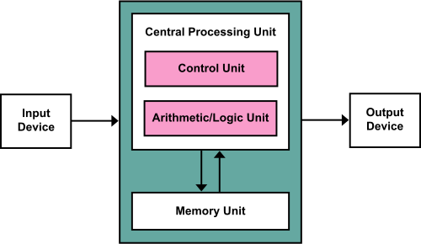
Basic Diagram

Main Components

1. Memory Unit
Memory stores both instructions and data in the same storage area. The CPU retrieves instructions and data from memory when needed.

2. Control Unit (CU)
The Control Unit controls the activities of the computer. It fetches instructions, decodes them, and controls their execution.

3. Arithmetic Logic Unit (ALU)
The ALU performs arithmetic operations such as addition and subtraction and logical operations such as comparison and Boolean operations.

4. Registers
Registers are small, high-speed storage locations inside the CPU. They temporarily hold instructions, data, addresses, and intermediate results.

5. Input Unit
The input unit accepts data and instructions from the user and sends them to memory or the CPU for processing.

6. Output Unit
The output unit presents the processed results to the user through devices such as monitors and printers.

Working of Von Neumann Model
The model follows the fetch–decode–execute cycle:
- Fetch: CPU fetches an instruction from memory.
- Decode: Control Unit interprets the instruction.
- Execute: ALU or another CPU component performs the required operation.
- Store: The result is stored in memory or a register.
- The CPU repeats the cycle for the next instruction.

Important Features
- Single memory stores both data and instructions.
- Uses a stored-program concept.
- Instructions are normally executed sequentially.
- CPU consists mainly of ALU, Control Unit, and registers.
- Communication occurs through buses.
- It provides a simple and flexible structure for general-purpose computers.

Main Limitation: Von Neumann Bottleneck
Because instructions and data share the same memory and communication path, the CPU may have to wait while transferring them. This limitation is called the Von Neumann bottleneck.

Introduction to Number Systems in Computer
A number system is a method of representing numbers using a specific set of digits or symbols. In computers, number systems are used to represent, store, and process data and instructions.
Computers mainly use the binary number system because electronic circuits work with two states: ON (1) and OFF (0).
A number system is a systematic way of representing numbers using a specific set of digits and a base. In computers, binary, octal, decimal, and hexadecimal number systems are commonly used.

Types of Number Systems
There are four commonly used number systems in computers:
Number System | Base (Radix) | Digits Used | Example
Binary | 2 | 0, 1 | (1011)₂
Octal | 8 | 0–7 | (25)₈
Decimal | 10 | 0–9 | (125)₁₀
Hexadecimal | 16 | 0–9, A–F | (2A)₁₆

1. Binary Number System
The binary system has a base of 2 and uses only 0 and 1.
- Each digit is called a bit.
- It is the fundamental number system used by computers.
- Example: (10101)₂
Example conversion:
(1011)₂ = 1×2³ + 0×2² + 1×2¹ + 1×2⁰
= 8 + 0 + 2 + 1
= 11₁₀
Example:
(1011)₂ can be written as
(1011)₂ = 1 × 2³ + 0 × 2² + 1 × 2¹ + 1 × 2⁰
(1011)₂ = 1 × 8 + 0 × 4 + 1 × 2 + 1 × 1
(1011)₂ = 11 (in decimal)

2. Octal Number System
The octal system has a base of 8 and uses digits from 0 to 7.
- One octal digit represents 3 binary bits.
- It provides a shorter representation of binary numbers.
- Example: (725)₈

- Example:
- (325)₈ can be written as
(325)₈ = 3 × 8² + 2 × 8¹ + 5 × 8⁰
(325)₈ = 192 + 16 + 5
(325)₈ = 213 (in decimal)

3. Decimal Number System
The decimal system has a base of 10 and uses digits from 0 to 9.
- It is the number system commonly used by humans in everyday life.
- Each position has a power of 10.
- Example: (256)₁₀
Example:
256 = 2×10² + 5×10¹ + 6×10⁰
Example:
10285 can be written as
10285 = (1 × 10⁴) + (0 × 10³) + (2 × 10²) + (8 × 10¹) + (5 × 10⁰)
10285 = 1 × 10000 + 0 × 1000 + 2 × 100 + 8 × 10+ 5 × 1
10285 = 10000 + 0 + 200 + 80 + 5
10285 = 10285

4. Hexadecimal Number System
The hexadecimal system has a base of 16.
It uses:
0, 1, 2, 3, 4, 5, 6, 7, 8, 9, A, B, C, D, E, F
Here, A = 10, B = 11, C = 12, D = 13, E = 14, F = 15.
- One hexadecimal digit represents 4 binary bits.
- It is widely used in programming, memory addresses, machine code, and color codes.
- Example: (2F)₁₆

- Example:
- (2F)₁₆ can be written as
(2F)₁₆ = 2 × 16¹ + F × 16⁰
(2F)₁₆ = 2 × 16 + 15 × 1
(2F)₁₆ = 32 + 15
(2F)₁₆= 47 (in decimal)

Positional Value
The value of a digit depends on its position and the base/radix of the number system.
For a number:
(1011)₂
1 0 1 1
↓ ↓ ↓ ↓
2³ 2² 2¹ 2⁰
Therefore:
1×8 + 0×4 + 1×2 + 1×1 = 11

Why Number Systems Are Important
- They help computers represent data and instructions.
- Binary is used directly by digital electronic circuits.
- Octal and hexadecimal make long binary numbers easier to read and write.
- Decimal is convenient for human interaction and calculations.
- Number-system conversions are important in computer programming, networking, digital electronics, and computer architecture.

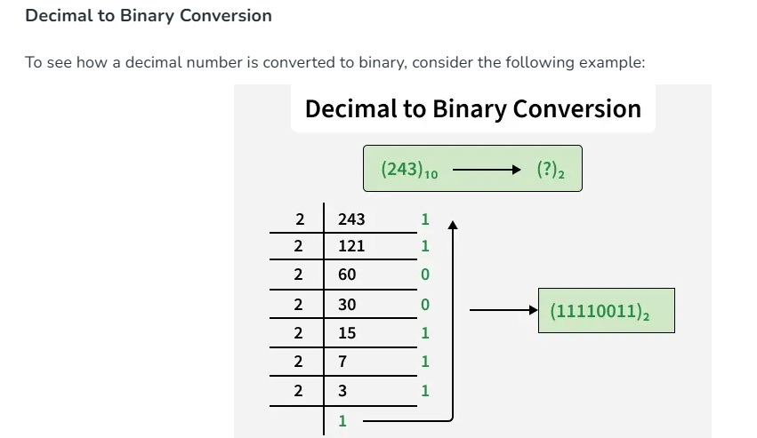

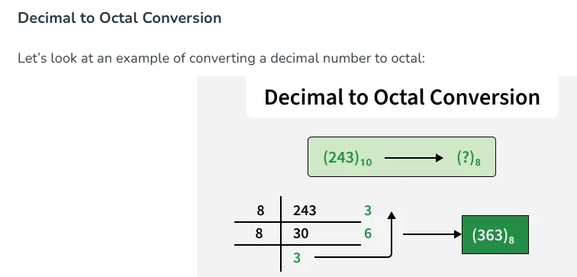

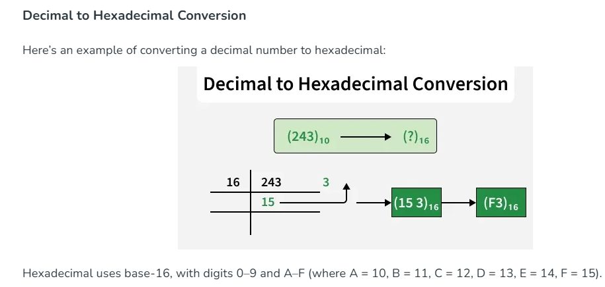

Example 1. Convert (1101)₂ into a decimal number.
Solution: Given a binary number (1101)₂.
Now, multiplying each digit from MSB to LSB with reducing the power of the base number 2.
1 × 2³ + 1 × 2² + 0 × 2¹ + 1 × 2⁰
= 8 + 4 + 0 + 1
= 13
Therefore, (1101)₂ = (13)₁₀
Octal to Decimal:
To convert octal to decimal, we multiply the digits of octal number with decreasing power of the base number 8, starting from MSB to LSB and then add them all together.
Example 2: Convert 22₈ to decimal number.
Solution: Given, 22₈
2 x 8¹ + 2 x 8⁰
= 16 + 2
= 18
Therefore, 22₈ = 18₁₀
Hexadecimal to Decimal:
Example 3: Convert 121₁₆ to decimal number.
Solution: 1 x 16² + 2 x 16¹ + 1 x 16⁰
= 16 x 16 + 2 x 16 + 1 x 1
= 289
Therefore, 121₁₆ = 289₁₀

Example: Convert (89)₁₆ into a binary number.
Solution: From the table, we can get the binary value of 8 and 9, hexadecimal base numbers.
8 = 1000 and 9 = 1001
Therefore, (89)₁₆ = (10001001)₂

Example: Convert (214)₈ into a binary number.
Solution: From the table, we know,
2 → 010
1 → 001
4 → 100
Therefore,(214)₈ = (010001100)₂

Practice Problems on Number System Conversion
- Convert 146₁₀ into a binary number system
- Convert 1A7₁₆ into the decimal number system
- Convert (110010)₂ into octal number system
- Convert DA2₁₆ into the binary number system
- Convert 4652₈ into the binary number system

Data Representation: ASCII and Unicode
Data representation means the way a computer stores and represents data such as characters, numbers, symbols, images, and instructions in digital form. Since computers work with binary (0 and 1), characters are converted into numerical codes so that they can be stored and processed.

1. ASCII
ASCII (American Standard Code for Information Interchange) is a character-encoding standard used to represent letters, numbers, and symbols.

Main Points of ASCII
- Standard ASCII uses 7 bits and can represent 128 characters.
- It represents English uppercase and lowercase letters, digits, punctuation, and control characters.
- A = 65, B = 66, a = 97, and 0 = 48 in decimal.
- ASCII can be represented in binary, for example A = 1000001₂.
- Extended ASCII commonly uses 8 bits, allowing up to 256 values, although different extended-ASCII variants are not all the same.
- ASCII is widely used for basic English text and is also a foundation for many modern character encodings.

Example
Character | ASCII Decimal | Binary
A | 65 | 1000001
B | 66 | 1000010
a | 97 | 1100001
1 | 49 | 0110001

2. Unicode
Unicode is a universal character-encoding system designed to represent characters from many languages and writing systems around the world.

Main Points of Unicode
- Unicode can represent characters from languages such as English, Nepali, Hindi, Chinese, Arabic, Japanese, and many others.
- It also supports mathematical symbols, technical symbols, and emoji.
- Every Unicode character is assigned a unique code point, written like U+XXXX.
- For example, A = U+0041 and the Nepali character क = U+0915.
- Unicode can be encoded using formats such as UTF-8, UTF-16, and UTF-32.
- UTF-8 is especially common on the Web and is compatible with ASCII for the basic 128 characters.

Examples
Character | Unicode Code Point
A | U+0041
a | U+0061
क | U+0915
न | U+0928
😊 | U+1F60A

ASCII vs Unicode
Feature | ASCII | Unicode
Full form | American Standard Code for Information Interchange | Unicode
Main purpose | Mainly basic English characters | Characters from many writing systems
Standard ASCII size | 7 bits | Uses code points; encoded using UTF-8/16/32
Characters | 128 | Over 1 million possible code points
Languages | Mainly English | Global languages and symbols
Example | A = 65 | A = U+0041
Nepali support | ❌ No | ✅ Yes
Emoji support | ❌ No | ✅ Yes

Example
When you type:
Hello
The computer does not store the letters directly as human-readable letters. They are represented using character codes and ultimately stored as binary data.

BCD in Data Representation
BCD (Binary Coded Decimal) is a method of representing decimal digits (0–9) using 4 binary bits.
Important: BCD is mainly used for digits 0–9, not directly for letters A–Z or a–z. Letters are represented using codes such as ASCII or Unicode.

1. BCD Table for Decimal Digits
Decimal | BCD
0 | 0000
1 | 0001
2 | 0010
3 | 0011
4 | 0100
5 | 0101
6 | 0110
7 | 0111
8 | 1000
9 | 1001

2. Example: Represent 25 in BCD
Each decimal digit is converted separately:
2 → 0010
5 → 0101
Therefore:
25₁₀ = 0010 0101 (BCD)
⚠️ BCD is not the same as pure binary.
For example, binary of 25 is 11001, while BCD is 0010 0101.

3. What about A–Z and a–z?
For letters, we normally use ASCII, not BCD.
Character | ASCII Decimal | 8-bit ASCII
A | 65 | 01000001
B | 66 | 01000010
C | 67 | 01000011
... | ... | ...
Z | 90 | 01011010
a | 97 | 01100001
b | 98 | 01100010
c | 99 | 01100011
... | ... | ...
z | 122 | 01111010

Easy way to remember
BCD → Decimal digits (0–9)
ASCII → Characters (A–Z, a–z, 0–9, symbols)
Unicode → Characters from many languages and writing systems
Example:
25 → BCD: 0010 0101
A → ASCII: 01000001
a → ASCII: 01100001

